**W3Schools.com**

"Never increase, beyond what is necessary, the number of entities required to explain anything." William of Ockham (1285-1349)

**Free Web Building Tutorials**

At W3Schools you will find all the Web-building tutorials you need, from basic HTML and XHTML to advanced XML, XSL, Multimedia and WAP.

W3Schools - The Largest Web Developers Site On The Net!

Copyright 1999-2005 by Refsnes Data.

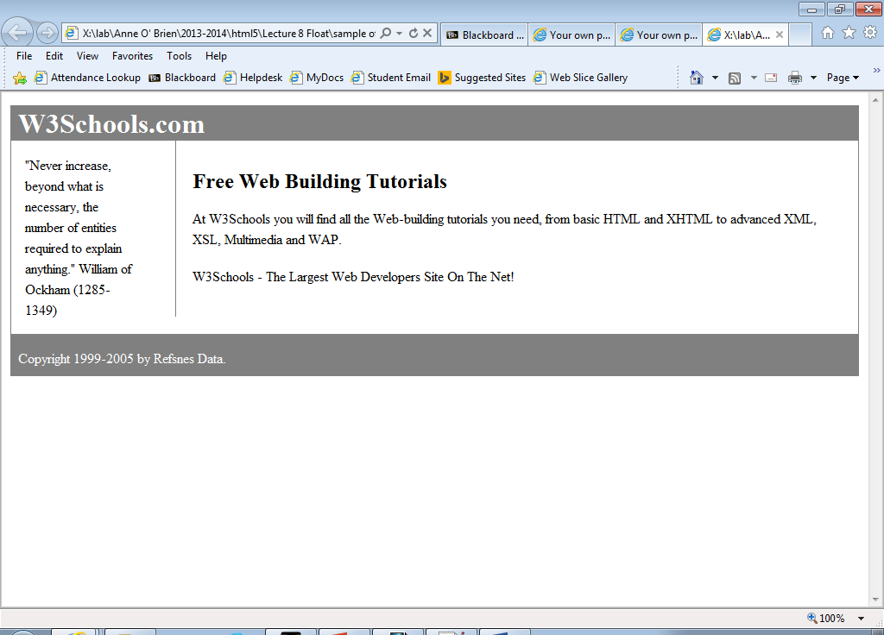

line-height:150%;